Lab task 12.1

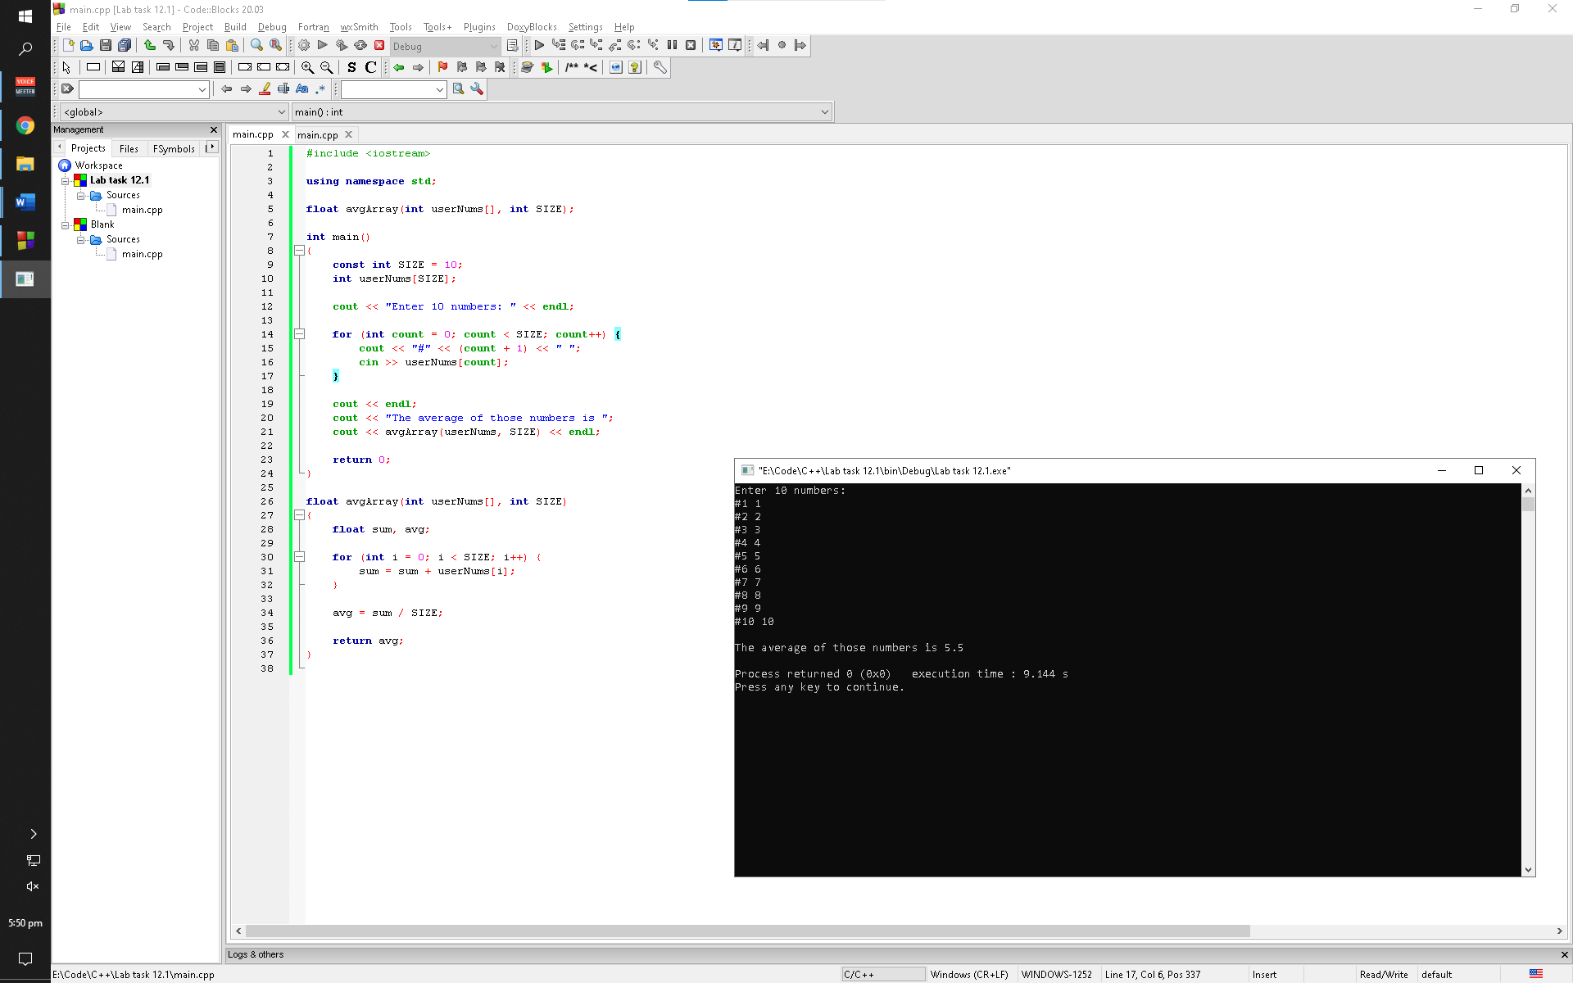

Observation: This program asks the user to enter any ten integers and stores them into any array. It then calls a function which then add all of those integers to find the average. The function returns the average to the main function that is then printed out to the user

Lab task 12.2

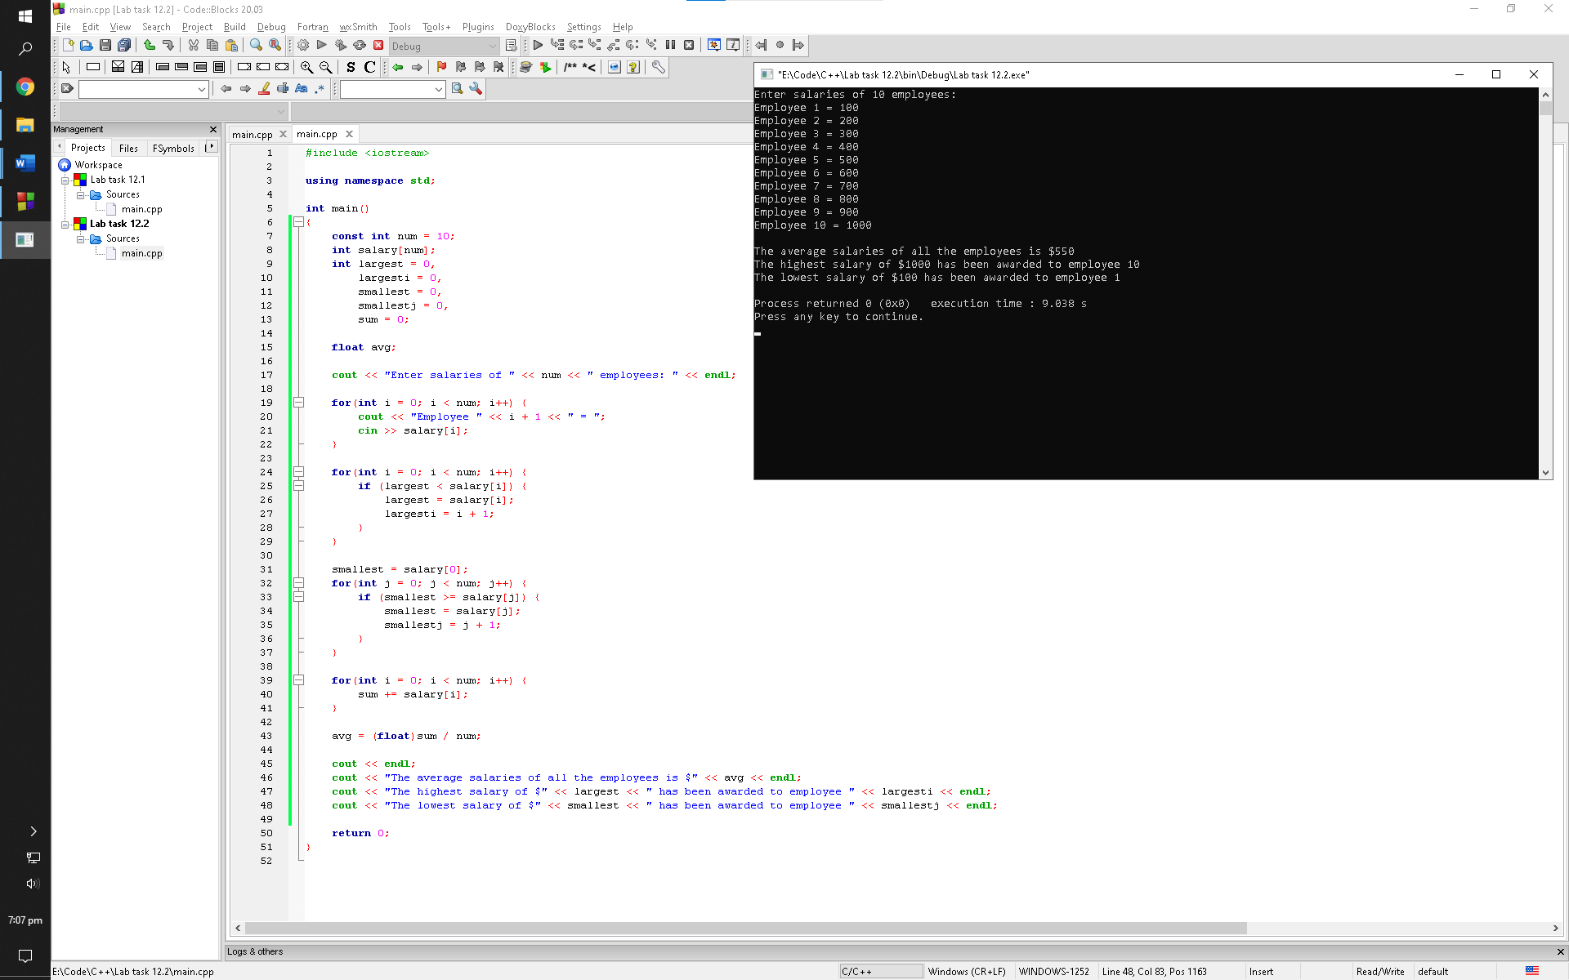

Observation: This program asks the user to enter salaries of ten employee and stores them into an array. It then uses that array to find out who had the highest salary, who had the lowest salary, and the average of those salaries. The program prompts the user with the values in the end

Lab task 12.3

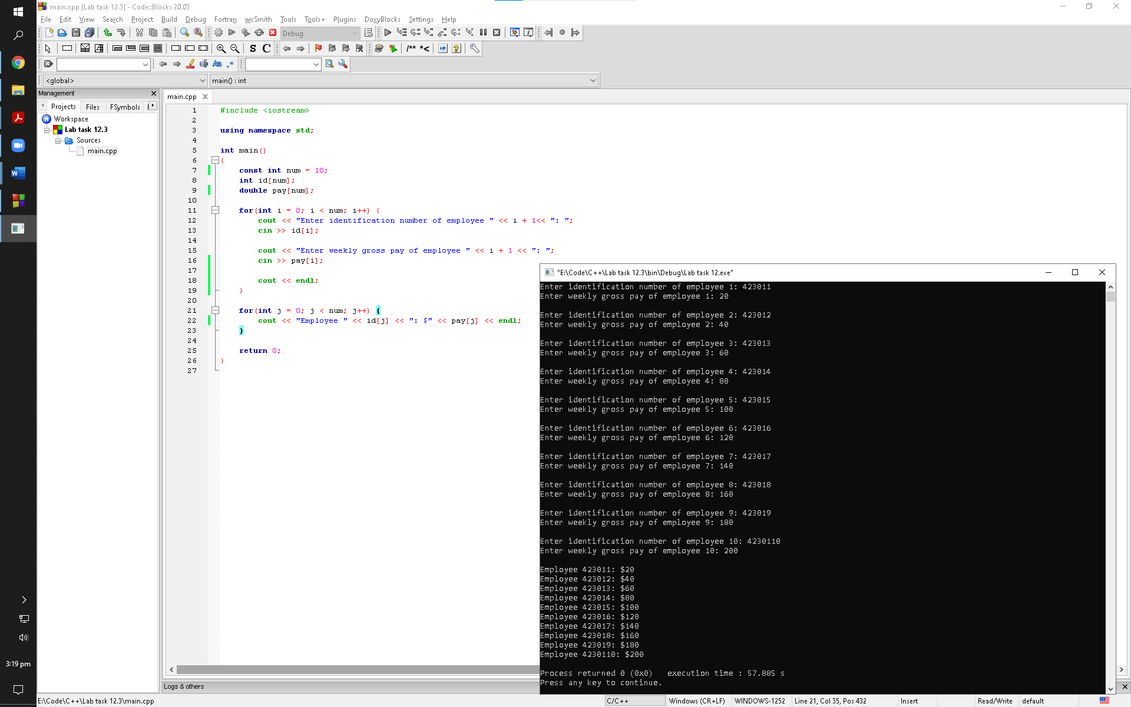

Observation: This program asks the user to enter the id number of employees along with their gross pays; all of this information is stored in two arrays. The program then uses those arrays and prints the gross pay amount of employees along with their id numbers

Post lab 12

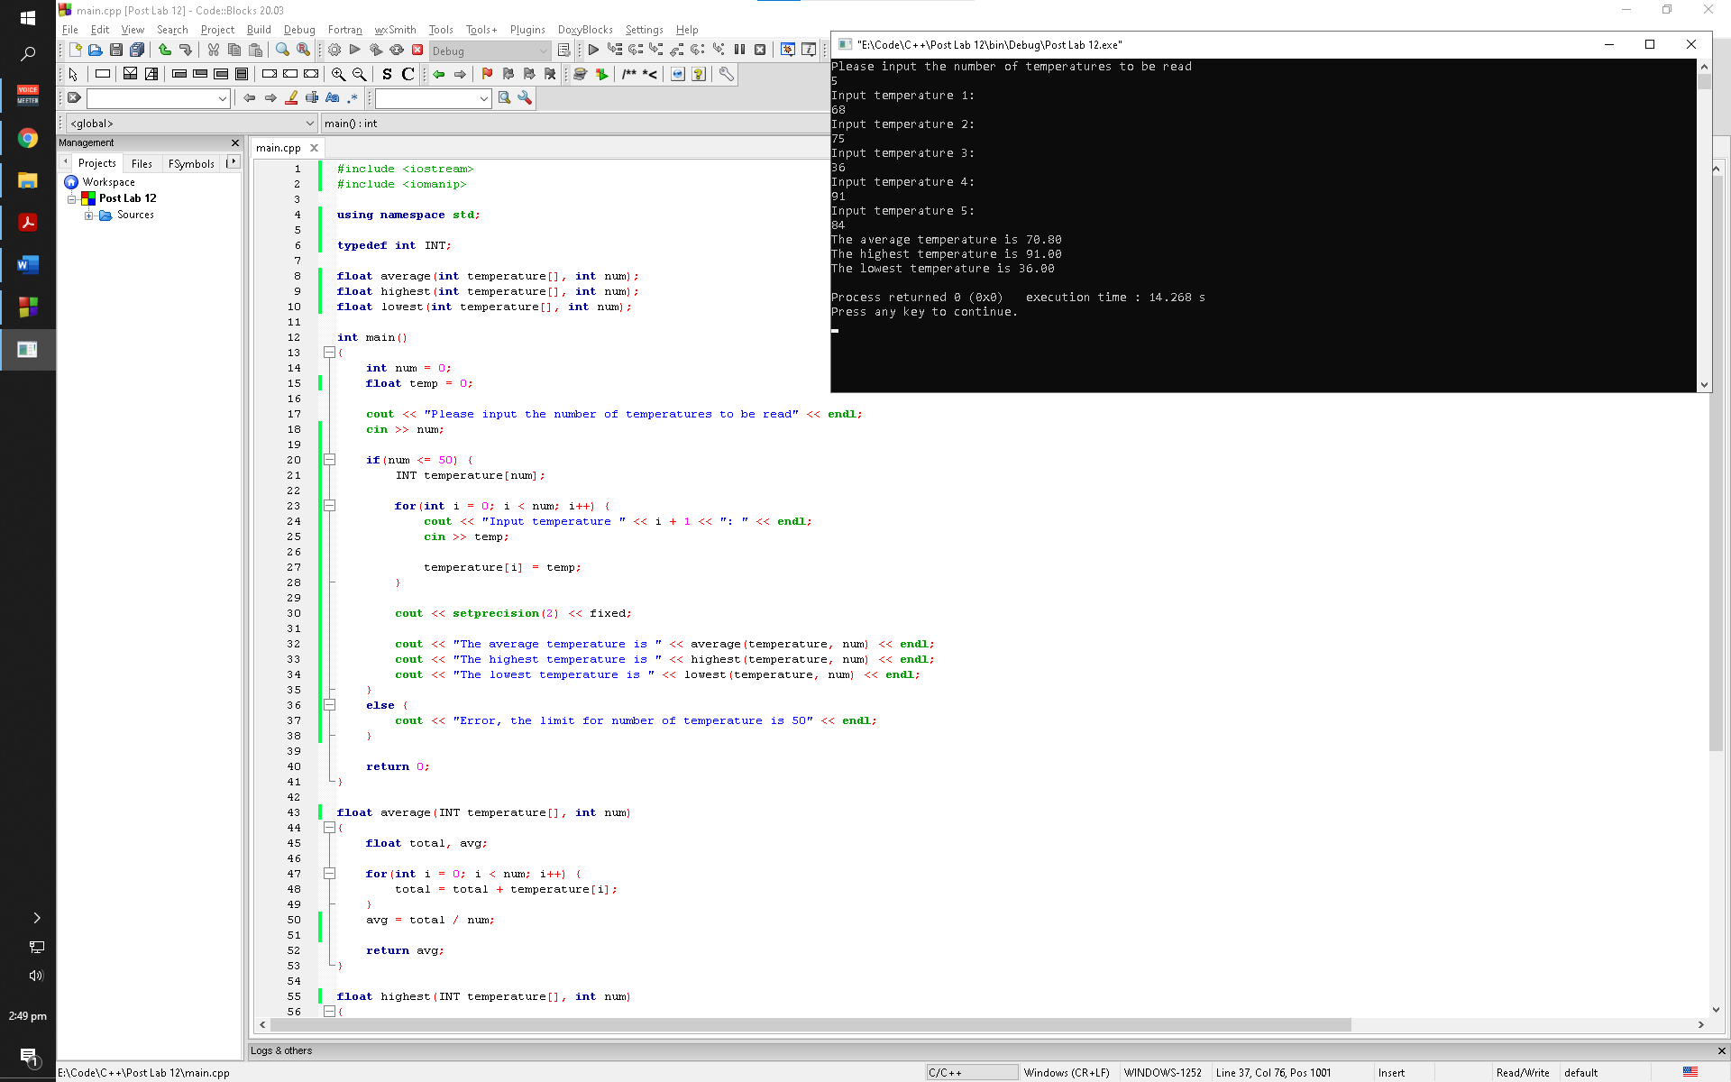

Observation: This program prompts the user to enter the number of temperatures he/she want to process. It then uses a loop to ask the user the temperature values until the loop arrives to the number of temperatures value the user had entered before. First, the program calls a function to take out the average of those values and return the average value back to the main function which is then printed out to the user. Second, the program calls a function to find the highest temperature value among them by comparing them with each other; the highest value is then returned back to the main function and it printed out to the user. Third, the program calls a function to find the lowest temperature value among them by comparing them with each other; the lowest value is then returned back to the main function and it printed out to the user